Create a Tableau Dashboard with appropriate filtering as shown in class. Use another dataset for your example, maybe the geographical map along with time and boxplots of the fbi crimes dataset??

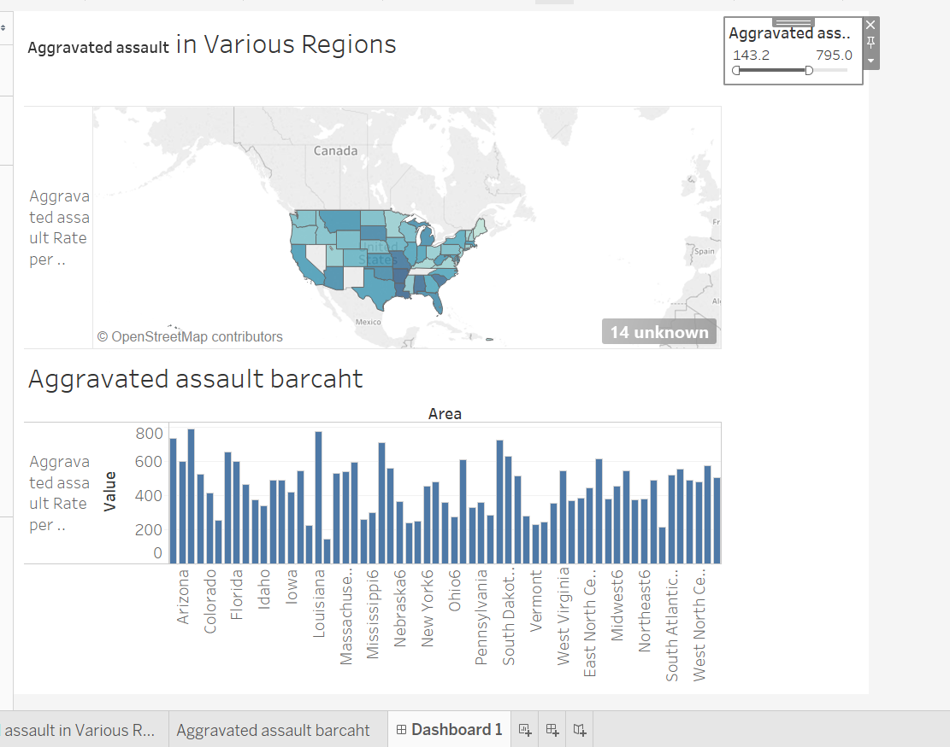

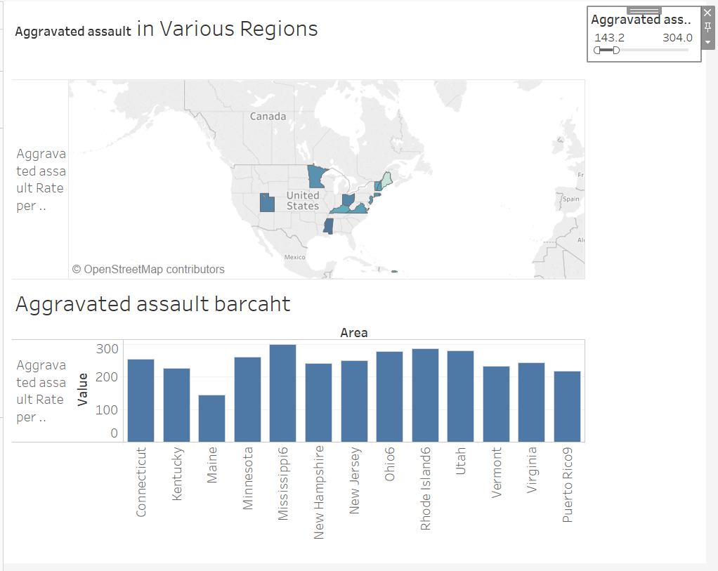

We can now filter various regions based of number of aggravated assault (in total).